# CS 255 System Design Document Template

This template lays out all the different sections that you need to complete for Project Two. Each section has guidance to prompt your thinking. You will need to continually reference the interview transcript as you work to make sure that you are addressing your client’s needs. There is no required length for the final document. Instead the goal is to complete each section based on what your client’s needs are. Remove this note when you are finished, and replace all bracketed text with the relevant information.

## UML Diagrams

### UML Use Case Diagram

*[In Module Six, you were asked to complete a use case diagram based on your system design. If you would like to make any adjustments to your diagram, please do so. Please insert your use case diagram here. Check to make sure that you included appropriate components and symbols and that your design meets the client’s needs.]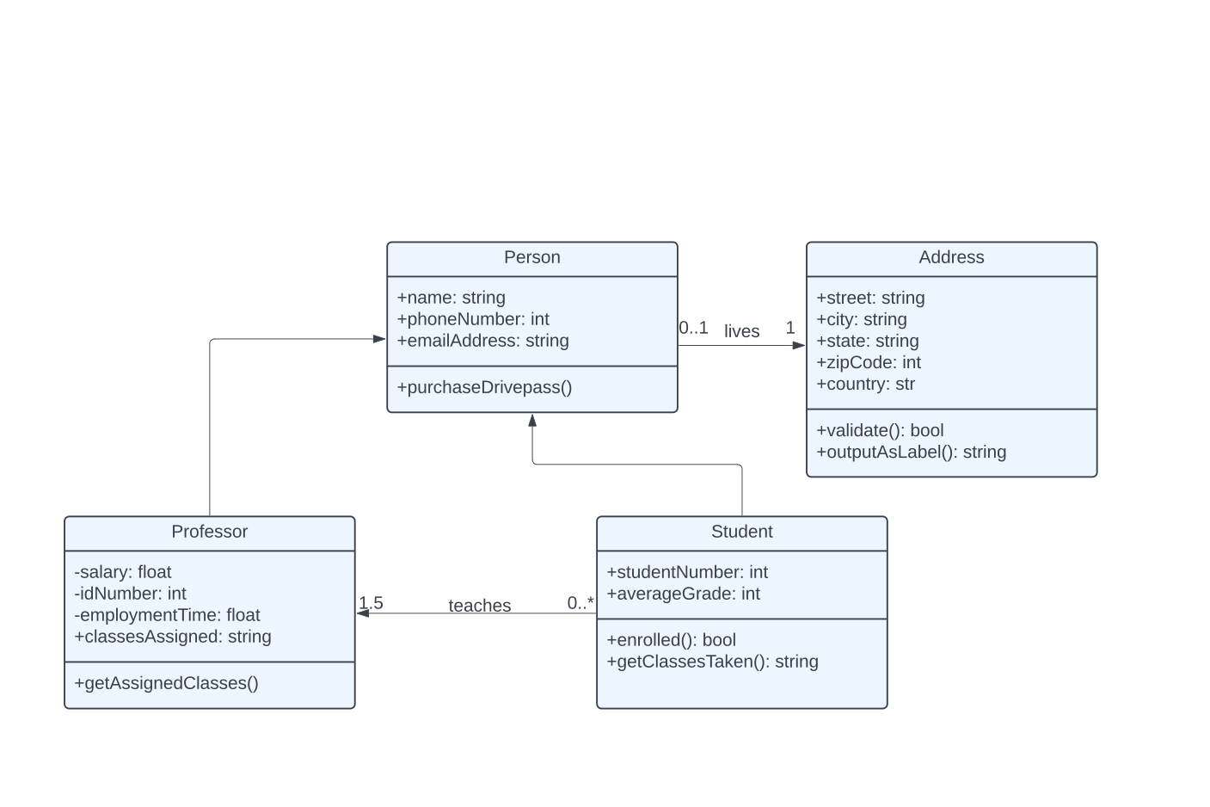*

### UML Activity Diagrams

*[You were asked to choose* ***two*** *use cases and create* ***two*** *activity diagrams, one for each use case. Please insert* ***both*** *of your activity diagrams here. Check to make sure that you included appropriate components and symbols and that your design meets the client’s needs.]*

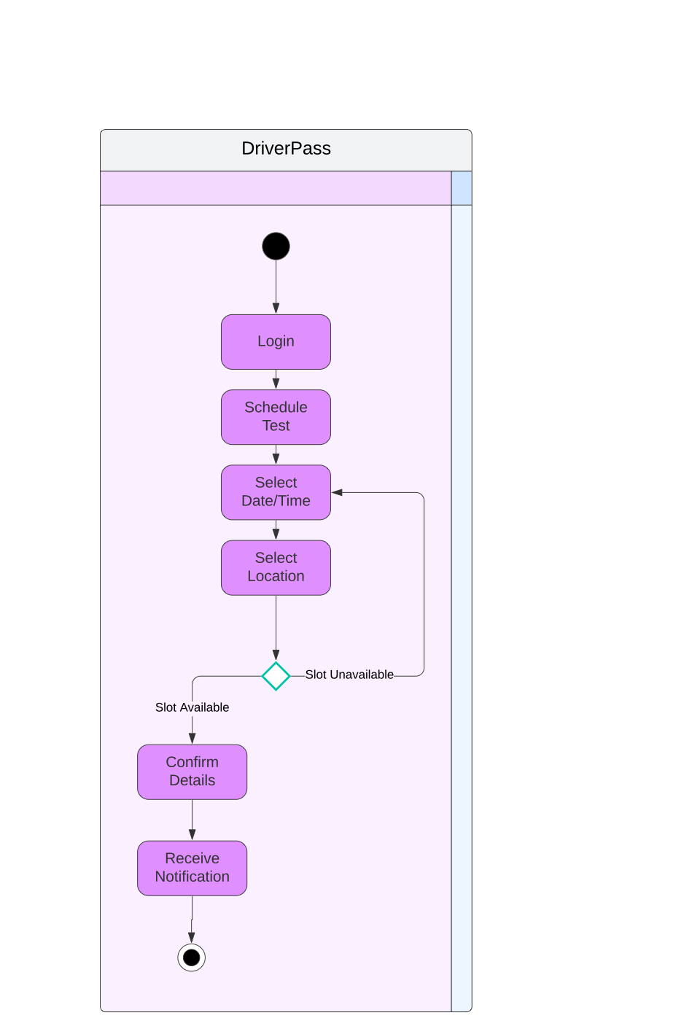

### UML Sequence Diagram

*[You were asked to create a sequence diagram based on* ***one*** *of the use cases you chose. Please insert your sequence diagram here. Check to make sure that you included appropriate components and symbols and that your design meets the client’s needs.]*

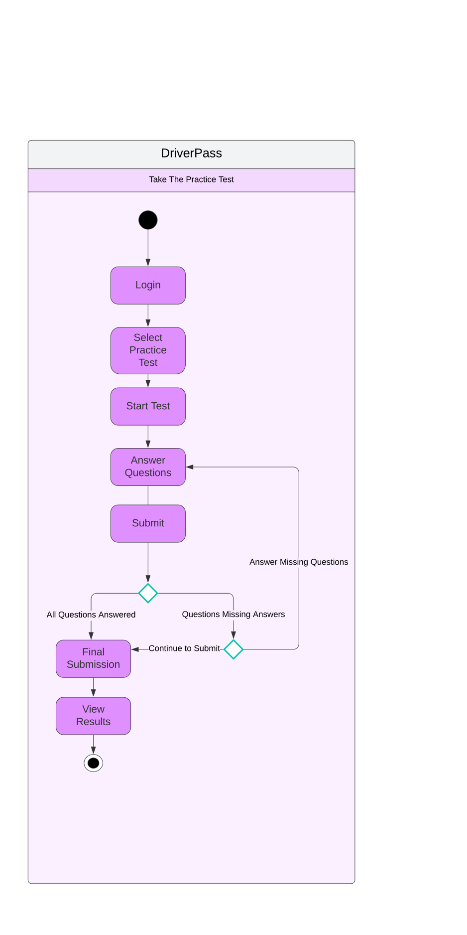

### Blank diagram-4.pdf

### UML Class Diagram

*[You were asked to create a class diagram based on the different classes and attributes needed for your system design. You are* ***not*** *required to include methods, but you may if you wish. Please insert your class diagram here. Check to make sure that you included appropriate components and symbols and that your design meets the client’s requirements.]*

## Blank diagram-5.pdf

## Technical Requirements

*[Based on the diagrams you have created, describe the technical requirements of your system. These requirements should address the required hardware, software, tools, and infrastructure necessary for your system design.]*

* *This system will need to be web based and and should be compatible with various popular web browsers such as Chrome, Edge, Safari, Firefox, and the mobile versions of these browsers as well.*
* *The response times for this system should be reasonably quick loading pages and completing operations within just a few seconds.*
* *The system should be updated on regularly scheduled intervals, but also should incorporate as needed updates for bugs fixes and Security updates.*
* *The system should be compatible with all of the major operating systems such as Windows, MacOS, Linux, and Chrome OS. The differences between different operating systems should be negligible.*
* *The system will need to be hosted on a reliable web server such as Apache and a server side scripting language such as Python.*
* *The most ideal way to host the system should be utilizing a cloud platform such as Microsoft Azure which will allow for easier data management and assist with scalability.*
* Users should be able to authenticate using a username and password.
* A multi-factor authentication system should also be implemented such as sending a text message to the user’s phone an entering a unique code.
* Encryption of user data using SSL or TLS to protect stored user data.
* If there is a brute force hacking attempt, there should be an operation in place to lock the user account and notify the IT admin of the activity.